Understanding by Design Unit Template
T:\Smartboard\Mathematics\Grade 9\UBD Units\Polynomials unit

Title of Unit |  | Polynomials |  | Grade Level |  | 9
Curriculum Area |  | Math |  | Time Frame |  | 3 Weeks
Developed By
School
Identify Desired Results (Stage 1)
Content Standards –Curricular Outcomes
P9.4 Demonstrate understanding of polynomials (limited to polynomials of degree less than or equal to 2) including:
- modeling
- generalizing strategies for addition, subtraction, multiplication, and division
- analyzing
- relating to context
- comparing for equivalency.
[C, CN, R, V]

Essential Questions |  |  | Enduring Understandings
Open-ended questions that stimulate thought and inquiry linked to the content of the enduring understanding. |  |  | What do you want students to understand & be able to use several years from now?
- Why are letters used in mathematical expressions and equations? What purpose do they serve?  - Can two algebraic expressions that appear to be different be equivalent?  - How are polynomials classified?  - What strategies can be used to add, subtract, multiply, or divide polynomials? |  |  | - The properties of integers apply to polynomials.  - Polynomials can be used to model real world situations.
 |  |  | Misconceptions
 |  |  | (Optional)
- That two expressions that appear to be different can still be equivalent
- Students may have difficulty recognizing that the properties and operations for integers is the same as that for polynomials.
- Students may have misconceptions around “like terms”. For example, students may recognize that 1 – 1 = 0 but have difficulty recognizing that x – x = 0 or that x² - x ≠ 0

Knowledge  Students will know… |  |  | Skills  Students will be able to…
- What a polynomial is.  - The different parts of a polynomial  - The types of polynomials  - What it means for polynomials to be equivalent  - That polynomials can be written in different ways and still be equivalent  - That properties of integers apply to polynomials |  |  | - Classify polynomials  - Identify the parts of a polynomial.  - Determine if two polynomials are equivalent  - Add and subtract polynomials  - Multiply and divide polynomials (including multiplying and dividing a polynomial by a constant as well as by a monomial)  - Apply addition, subtraction, multiplication, and division of polynomials to situational problems
Assessment Evidence (Stage 2)
Performance Task Description
The performance task describes the learning activity in “story” form. Typically, the P.T. describes a scenario or situation that requires students to apply knowledge and skills to demonstrate their understanding in a real life situation. Describe your performance task scenario below: |  |  |  |  |  |  | Helpful tips for writing a performance task.
Performance Task: Adding, Subtracting, Multiplying and Dividing Polynomials  Goal: Your goal is to correctly calculate the dimensions of a house by adding, subtracting, and multiplying polynomials.  Role: You are a construction worker helping to build a house.  Audience: The teacher and the class.  Situation: You are helping your cousin build a house! The layout of the first floor is shown in the diagram below. You are helping him determine all the dimensions of his new home.  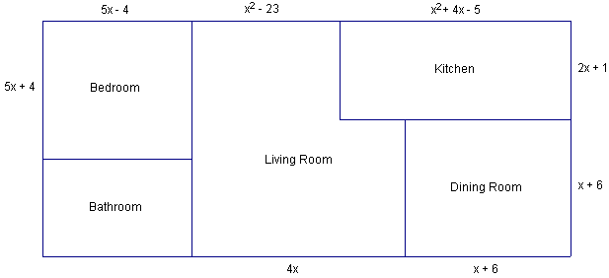  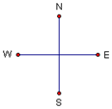  Product: Using the diagram above and your knowledge of polynomials find the following:  - Write a polynomial that represents the length of the north side of the house. Then simplify the expression.  - Your cousin said the length of the north side of the house is 9y +2y² – 32.  - Is he correct?  - How do you know?  - Write a polynomial expression that represents the area of the kitchen. Then multiply to put the polynomial in standard form. Is the area an example of a trinomial, a binomial, or a monomial?  - Write a polynomial expression that represents the area of the bedroom. Then multiply to put the polynomial in standard form.  - For the area of the bedroom you just found, state the following:  - Variable:  - Coefficient(s):  - Constant Term:  - Degree:  - Find the dimensions of the bathroom in terms of x. (Hint the west and east side of the house should be equal.)  - You decided to add 2 more bedrooms to the West side of the house, but you still want the outside shape of the house to remain a rectangle. You must decide what dimensions you want the rooms to be, written in the form of a polynomial. Remember, the East and West sides of the house still need to be equal.  - Draw each room and label the dimensions.  - Find the area of each new room.  - Write a polynomial that represents the side of the house with the new rooms. Then simplify the expression.  - You and your cousin decide that you want to put a deck on the East side of the house. Your cousin also wants to place 3 evenly spaced decorative pillars on the deck. How far apart do the posts need to be? Give your answer as a polynomial.  - To build the walls on the two outside corners of the bedroom, your cousin wants to use sheets of dry wall that are each x in length. How many sheets of dry wall will you need for the two outside walls of the bedroom.  *See attached copy for student handout  Standards:  - Questions and corresponding level on rubric written in brackets following each description |  |  |  |  |  |  | Goal:  What should students accomplish by completing this task?
  Outcome P9.4A Students will be able to recognize, write and classify polynomials.
  Beginning (1) | Approaching(2) | Proficiency (3) | Mastery (4)
  I need more help with becoming consistent with the criteria. | I can:  - identify monomials, binomials, trinomials  - identify the variable  - state the degree  - state the number of terms  - state the coefficients  - state the constant term (5) | I can:  - write a monomial binomial or trinomial  - compare/write equivalent polynomials (2a) | I can describe relationships between a variable in degree 1 and a variable in degree 2. I can analyze polynomials and discuss the significance of parts of the polynomial. (2b)
  Outcome P9.4B Students will be able to add and subtract polynomials.
  Beginning (1) | Approaching (2) | Proficiency (3) | Mastery (4)
  I need more help with becoming consistent with the criteria. | I can add polynomials (1) | I can subtract polynomials (6) | I can solve situational questions. (7)
  Outcome P9.4C Students will be able to multiply and divide polynomials.
  Beginning (1) | Approaching (2) | Proficiency (3) | Mastery (4)
  I need more help with becoming consistent with the criteria. | I can multiply a constant by a polynomial.  I can divide a polynomial by a constant (8) | I can multiply a monomial by a polynomial. (3, 4)  I can divide a polynomial by a monomial. (9) | I can solve situational questions. (7b)
Role:
What role (perspective) will your students be taking?
Audience:
Who is the relevant audience?
Situation:
The context or challenge provided to the student.
Product/Performance:
What product/performance will the student create?
Standards
(Create the rubric for the Performance Task)
BLOOMS TAXONOMY:  REMEMBERING: Can the students recall or remember the information?  UNDERSTANDING: Can the students explain ideas or concepts?  APPLYING: Can the students use the information in a new way?  ANALYZING: Can the students distinguish between the different parts?  EVALUATING: Can the students justify a stand or decision?  CREATING: Can the students create new product or point of view? |  | Digital Taxonomy for Bloom:  KNOWLEDGE: Highlighting, bookmarking, social networking, searching, googling  COMPREHENSION: Advanced searches, blog journaling, twittering, commenting  APPLICATION: Running, loading, playing, operating, hacking, uploading, sharing, editing  ANALYSIS: Mashing, linking, tagging, validating, cracking, reverse-engineering  SYNTHESIS: Programming, filming, animating, blogging, wiki-ing, publishing, podcasting, video casting  EVALUATION: Blog commenting, reviewing, posting, moderating, collaborating, networking, posting moderating
Standards Rubric
The standards rubric should identify how student understanding will be measured.
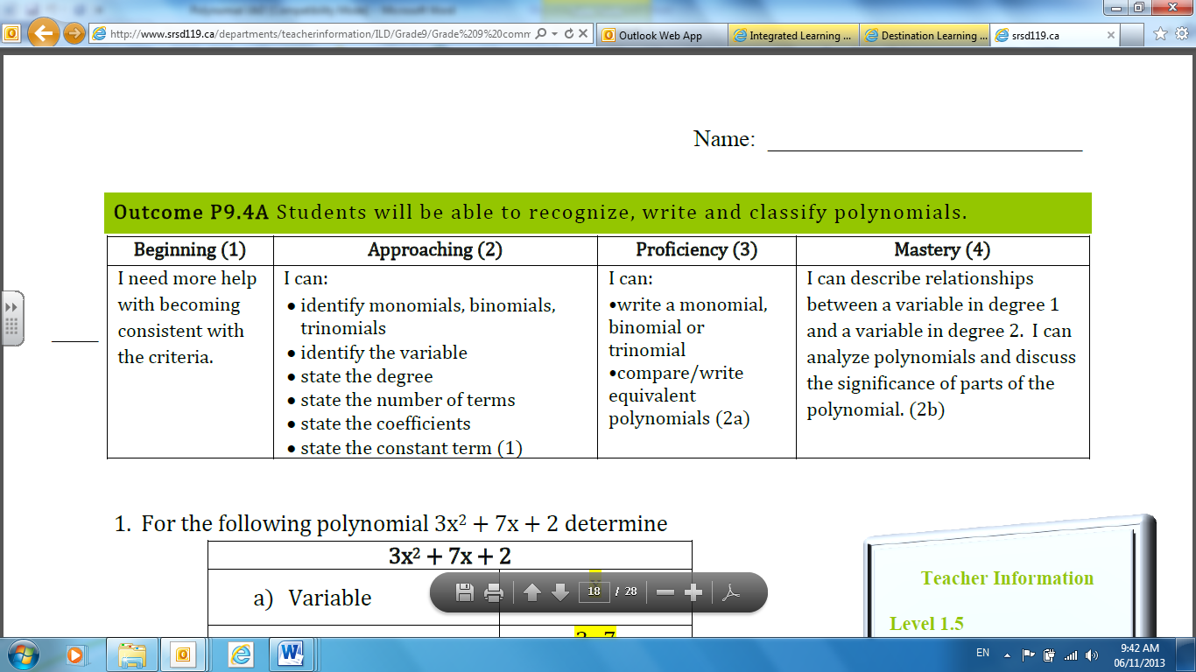
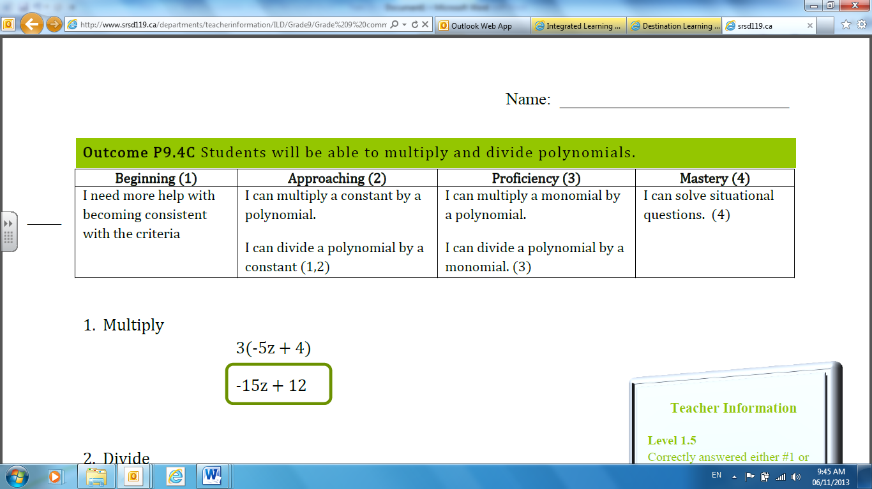
- This rubric will be used throughout the unit

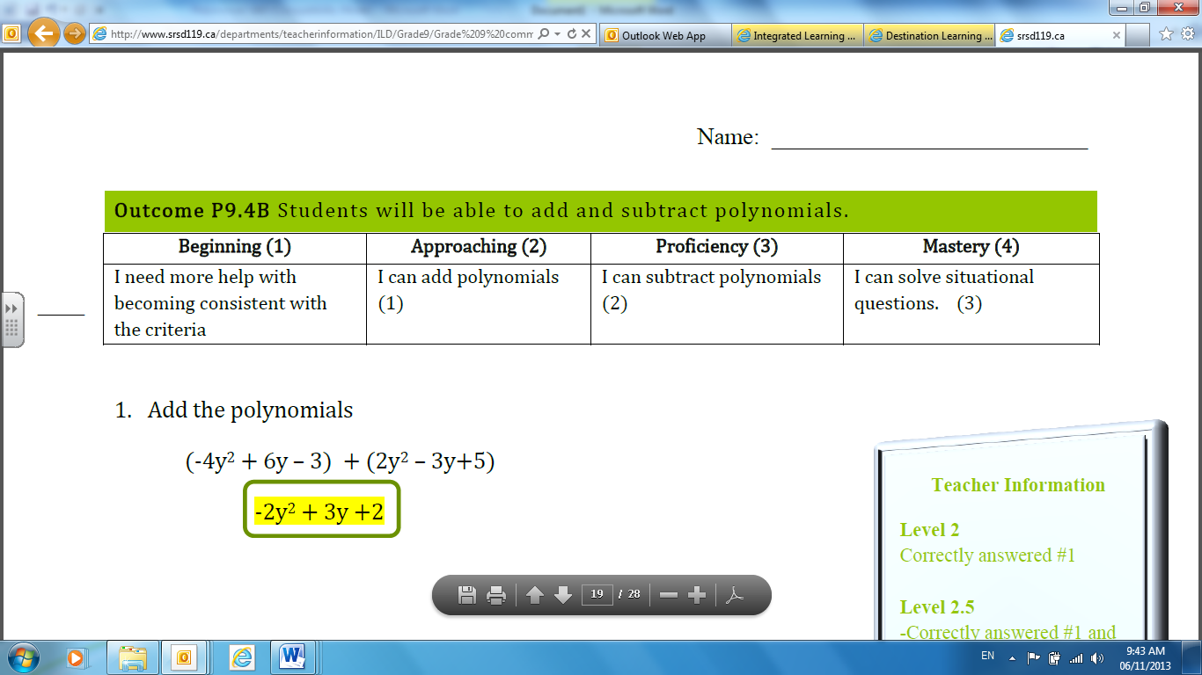

Other Assessment Evidence: (Formative and summative assessments used throughout the unit to arrive at the outcomes.)
Conversation | Observation |  |  |  | Product
Oral Conversations  Entrance Questions | Class Discussions  Individual Help |  |  |  | Entrance/Exit Slips  Textbook Assignments  Hand-In Assignments  SRSD Common Assessment
Learning Plan (Stage 3)
Where are your students headed? Where have they been? How will you make sure the students know where they are going?
- Present outcomes and performance task. Discuss what students will be doing and learning in this unit.

- Pre-assess prior knowledge of evaluating and simplifying expressions as well as modeling first degree expressions and equations using algebra tiles through the use of Entrance Questions.

How will you hook students at the beginning of the unit? (motivational set)
- Present students with the following scenario: Denali and Mehala weed the borders on the north and south sides of their rectangular yard. Denali starts first and has weeded 1 m on the south side when Mahala says he should be weeding the north side. So, Denali moves to the north side. Mahala finishes weeding the south side. Then she moves to the north side where she weeds 2m. Both students have then finished. Which student weeded more of the borders? How much more?
- Use this problem as a way to introduce students to polynomials. Have students build their own polynomial to help them represent this situation. Then explain what a polynomial is and that they can be used to represent all kinds of real world situations.
- Give students another real world example of where a polynomial could be used to represent a situation. Dan Meyer’s Three-Act Lesson: Will It Hit the Hoop? can quickly show students another scenario where polynomials are used. Quadratics are not studied until later grades, but this could still get them interested in the topic.

What events will help students experience and explore the enduring understandings and essential questions in the unit? How will you equip them with needed skills and knowledge? How will you organize and sequence the learning activities to optimize the engagement and achievement of all students?
Lesson 1: 5.1 Modeling Polynomials (P9.4 A)  - Students will learn how to model, write, and classify polynomials as either a monomial, binomial, or trinomial  - Have students investigate how to use tiles to model different polynomials. They can either use algebra tiles or draw pictures of the tiles in their books.  - SmartBoard Notes and Examples; Work through examples as a class.  - Assignment: Pages 214 – 216, #5 – 16, 18  Lesson 2: 5.2 Like Terms and Unlike Terms (P9.4 A)  - Students will learn what like and unlike terms are as well as how to simplify polynomials by combining like terms  - Students will need to recall what they learnt about adding and subtracting integers that a positive tile and a negative tile form a zero pair. This will help students make the necessary connections for grouping like terms and forming zero pairs with polynomials  - SmartBoard Notes and Examples  - Assignment: Pages 222 – 224, #4 – 11, 12 – 14 odd letters, 15, 18  Lesson 3: 5.3 Adding Polynomials (P9.4 B)  - Students will learn how to add polynomials by making connections between adding integers and combining like terms of polynomials  - SmartBoard Notes and Examples  - Assignment: Pages 228 – 230, #4 – 6, 8 – 10, 12, 17  Lesson 4: 5.4 Subtracting Polynomials (P9.4 B)  - Students will learn how to subtract polynomials by making connections between subtracting integers and combining like terms  - In this section students will see that subtracting integers is similar to what they already know how to do  - SmartBoard Notes and Examples  - Assignment: Pages 234 – 236, #5 – 10, 12, 13, 15, 16  Mid-Unit Assignment (P9.4 A and P9.4 B)  - Students will be assessed on outcomes P9.4 A and P9.4 B in this assignment  - The first part of the assignment is out of the textbook and will not be handed in  - The second part of the assignment is the hand-in portion that will be marked  Lesson 5: 5.5 Multiplying and Dividing a Polynomials by a Constant (P9.4 C)  - Students will learn how to multiply and divide polynomials by a constant  - They will make connections between tile models and the distributive property to generalize an algorithm for symbolically multiplying and dividing polynomials by a constant  - SmartBoard Notes and Examples  - Assignment: Pages 246 – 248, #5, 6, 12, 14 – 18, 20, 22, 23  Lesson 6: 5.6 Multiplying and Dividing a Polynomials by a Monomial (P9.4 C)  - Students will learn how to multiply and divide polynomials by a monomial by connecting it to prior learning in section 5.5  - SmartBoard Notes and Examples  - Assignment: Pages 255 – 257, #7, 9 – 14, 16, 17 a, 19 – 21  Review Assignment: P9.4 C  - Students will be assessed on outcome P9.4 C  - The first part of the assignment is out of the textbook, covers the entire unit and will not be handed in. The purpose of this section is additional practice and time for students to self-assess themselves on all the outcomes of this unit.  - The second part of the assignment is a hand-in that will specifically assess outcome P9.4 C. This will give students another opportunity to use the rubric to assess themselves and determine what areas they need additional work on before they do the Performance Task and Unit Test  Performance Task  - See above description of the Performance Task  Unit Test  - Use Saskatchewan Rivers School Division Common Assessments: P9.4 A – P9.4 C |  |  |  |  |  |  |  | Time Frame
2 Classes

2 Classes

2 Classes

2 Classes

1 – 2 Classes

2 Classes

2 Classes

1 – 2 Classes

1 Class

1 Class
How will you cause students to reflect and rethink? How will you guide them in rehearsing, revising, and refining their work based on your essential questions and enduring understandings?
- Entrance/Exit Slips
- Review Outline- Have them go through the outline and self-assess where they think they are before the test and identify what they need more work on to get to a level ¾
- Practice Assignments will give students an opportunity to practice the new skills they have learnt as well as identify areas of strength and areas of difficulty

How will you help students to exhibit and self-evaluate their growing skills, knowledge, and understanding throughout the unit?
- Students will have multiple opportunities to self-evaluate their own understanding throughout the unit. Students will answer Entrance and Exit Questions, participate in classroom discussions, and be given specific feedback on assignments. This will give students the chance to see what level they are currently at and then identify what specific skills or objectives they need to improve on in order to meet that outcome.

How will you tailor and otherwise personalize the learning plan to optimize the engagement and effectiveness of ALL students, without compromising the goals of the unit?
- Students will be shown more than one method for solving problems so that they introduced to one that makes the most sense to them. They will then be given the choice of how they will solve problems, using any of the methods investigated.
- Students will also be guided to develop strategies on their own for simplifying, adding, subtracting, multiplying and dividing fractions. This will help students develop a deeper understanding of the processes involved as well as allow for students to attempt a problem more than one way.

What resources will you use in the learning experiences to meet the outcomes?
- Math Makes Sense 9 Student Textbook
- Smart Notebook files containing investigation activities/questions, notes, and examples.

Assess and Reflect (Stage 4)
Required Areas of Study:
Is there alignment between outcomes, performance assessment and learning experiences?
BAL’s:
Does my unit promote life long learning, encourage the development of self and community, and engage students?
CELS & CCC’s:
Do the learning experiences allow learners to use multiple literacies while constructing knowledge, demonstrating social responsibility, and acting autonomously in their world?
Adaptive Dimension:
Have I made purposeful adjustments to the curriculum content (not outcomes), instructional practices, and/or the learning environment to meet the learning needs of all my students?
Instructional Approaches:
Do I use a variety of teacher directed and student centered instructional approaches?
Student Evaluation:
Have I included formative and summative assessments reflective of student needs and interests based on curricular outcomes?
Resource Based Learning:
Do the students have access to various resources on an ongoing basis?
FNM/I Content and Perspectives/Gender Equity/Multicultural Education:
Have I nurtured and promoted diversity while honoring each child’s identity?
Blueprint for Life:
Have I planned learning experiences in the unit that prepare students for a balanced life and/or work career?
Adapted from: Wiggins, Grant and J. McTighe. (1998). Understanding by Design, Association for Supervision and Curriculum Development.

